SCH4U - Acid-Base Review

- What defines a chemical as an Arrhenius acid? Base?

- What defines a chemical as a Bronsted-Lowry acid? Base?

- Name 2 everyday acids and 2 everyday bases.

- What defines a chemical as a strong acid? Base?

- What defines a chemical as a weak acid? Base?

- List 3 strong acids.

- Give an example of a weak acid.

- List 3 strong bases.

- Give an example of a weak base.

- What is the formula to determine the pH of a solution?

- What is the formula to determine the pOH of a solution?

- What is the pH of a solution of HCl with a concentration of 0.1M?

- What is the pOH of a solution of H₂SO₄²⁻ if its concentration is 0.05M?

- What type of reaction is the following: HCl + NaOH NaCl + H2O?

- What is an acid-base indicator?

- What is the concentration of [H+] and [OH-] ions at the equivalence point shown below?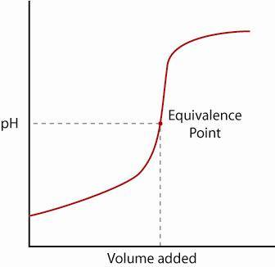

- Draw a sketch of the titration of a strong base with a weak acid.

- What is the pOH of a solution if the [H+] is 0.2M?

- Identify the acid, base, conjugate acid & conjugate base for the following equilibrium:

HS⁻(aq) + H₂O(l) ↔ H₂S(aq) + OH⁻ (aq)

- What is the [OH-] in a solution with a pH=9?

